Mousetrap Powered Vehicle

Name:
Class:
Design Completion Date
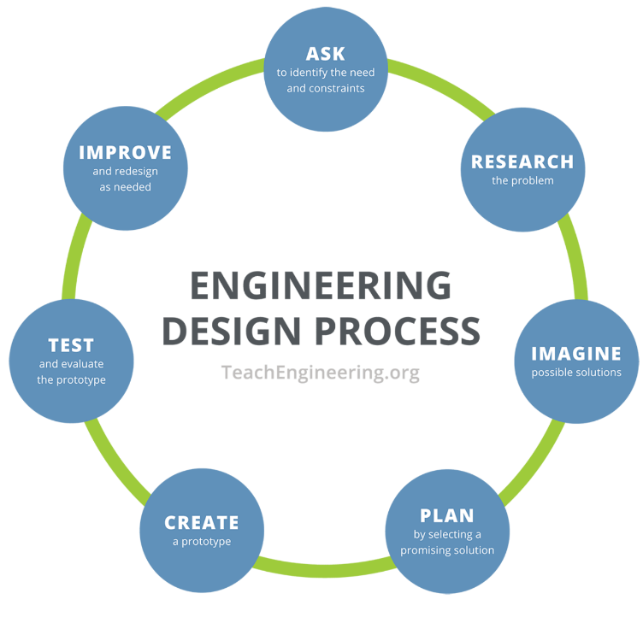

Design Challenge:
Build a vehicle that is powered by a single mousetrap. The goal is to create a vehicle that will travel as far as possible on a smooth flat surface (the gym floor).

Design Constraints:
No additional sources of energy may be added other than a single mousetrap.
Build materials are limited to what is available in the shop, though additional materials you provide can be approved by the teacher.

Reflection:
Follow the link on leitchtech.com and fill out the “Project Reflection” form on the Robotics page.

Assessment:

1 Emerging | 2 Approaching | 3 Proficient | 4 Extending

How well did you use the design cycle? ………………………………………………………………………. /4
Does your build reflect the Design Challenge description? …………………………………………… /4
Did you follow the Design Constraints? ………………………………………………………………………. /4
Did you complete the reflection form? …………………………………………………………………………. /4
Total: /16

