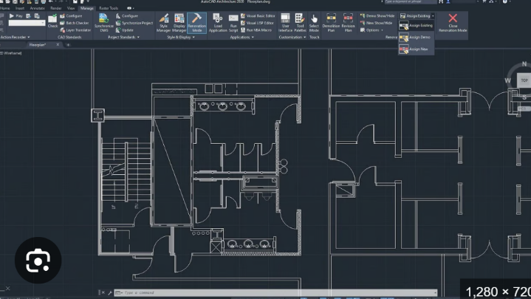
AutoCAD Project 1

Name:
Class:
Date:

Challenge

Design your perfect classroom in AutoCAD. You can design something other than a classroom, just check with your teacher first.

Constraints
Demonstrate the following: Array, copy, trim, chamfer, fillet, mirror, and applying OSNAP and layers.

Final Submission
Your final copy should be a PDF of Layout 1, using ANSI A paper size, and uploaded to leitchtech.com in the Design Draw tab.

Reflection

Fill out a reflection on the design process on leitchtech.com

Grading:
This project will be worth 25% of your final grade.
Did you design a classroom in AutoCAD? ……………………………………………………………………………………. /5
Did you follow the Challenge Constraints?....................................................................................... /5
Did you submit your AutoCAD PDF on leitchtech.com? ……………………………………………………………… /5
Is your PDF in ANSI A standards? ………………………………………………………………………………………………… /5
Did you fill out the Reflection Form on leitchtech.com? ……………………………………………………………… /5
Total /25

