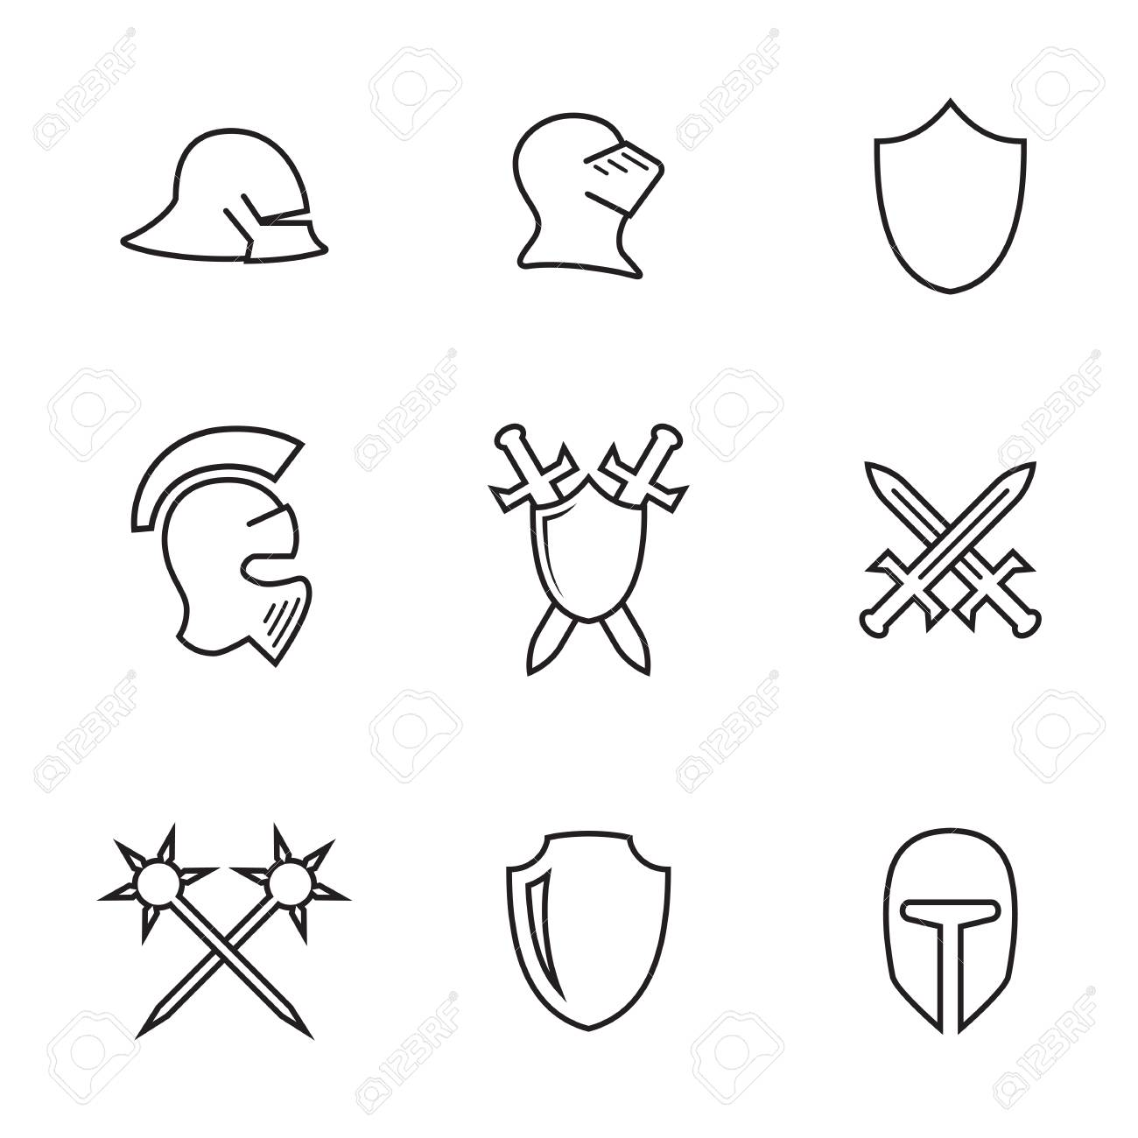

Social Studies 9

D&D Main Event

Name: | Historical Content: | Presenting Date:

Fill in the areas below. This can be point form. These will serve as a layout for putting your story together later. Brief notes here; this is not where you write your story.
Plot Overview
Introduction: (How will you introduce the players to the quest?)
________________________________________________________________________________________________________________________________________________________________________________________________
________________________________________________________________________________________________
________________________________________________________________________________________________
Transition: (Where will they travel to? What small events will happen on the way? Who will they encounter?)
________________________________________________________________________________________________________________________________________________________________________________________________
________________________________________________________________________________________________
________________________________________________________________________________________________
Main Event: (What is the critical event in the story? Who is involved? Where is it located?)
________________________________________________________________________________________________________________________________________________________________________________________________
________________________________________________________________________________________________
________________________________________________________________________________________________
________________________________________________________________________________________________
Conclusion: (How can the story end? It doesn’t need to always be historically accurate as long as the players know after)
________________________________________________________________________________________________________________________________________________________________________________________________________________________________________________________________________________________________________________________________________________________________________________________________________________________________________________________________________________________________
________________________________________________________________________________________________________________________________________________________________________________________________________________________________________________________________________________________________________________________________________________________________________________________________________
____________________________________________________________________________________________________________________________________________________________________________________________________
____________________________________________________________________________________________________________________________________________________________________________________________________
____________________________________________________________________________________________________________________________________________________________________________________________________
____________________________________________________________________________________________________________________________________________________________________________________________________
____________________________________________________________________________________________________________________________________________________________________________________________________
____________________________________________________________________________________________________________________________________________________________________________________________________
____________________________________________________________________________________________________________________________________________________________________________________________________
____________________________________________________________________________________________________________________________________________________________________________________________________________________________________________________________________________________________________________________________________________________________________________________________________________________________________________________________________________________________________________________________________________________________________________________________________________
____________________________________________________________________________________________________________________________________________________________________________________________________
____________________________________________________________________________________________________________________________________________________________________________________________________
____________________________________________________________________________________________________________________________________________________________________________________________________
____________________________________________________________________________________________________________________________________________________________________________________________________
____________________________________________________________________________________________________________________________________________________________________________________________________
____________________________________________________________________________________________________________________________________________________________________________________________________

