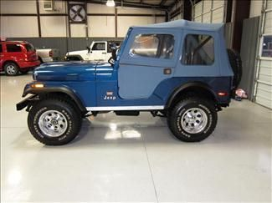

Automotive Technology 11/12
Jeep CJ5 Class Project
Transmission

Group:

Transmission:
Model:
Year:

Rebuild Resources:

Rebuild Shopping list:

