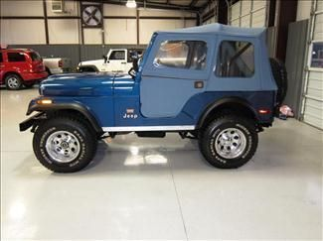

Automotive Technology 11/12
Jeep CJ5 Class Project
Engine

Group:

Engine:
Make:
Size:
Year:
Compression:
Cylinder | 1 | 2 | 3 | 4 | 5 | 6 | 7 | 8
Dry
Wet

Recommendation:

Rebuild Resource List:

Shopping list:

