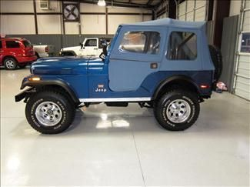

Automotive Technology 11/12
Jeep CJ5 Class Project
Brakes

Group:

Rotor:
Minimum thickness:
Measured thickness:
Measured runout:
Allowable runout:
Recommendation:

Brake pads:
Minimum thickness:
Measured thickness:
Recommendation:

Caliper Condition:
Leaks:
Tears:

Rebuild Shopping list:

